Azure Cloud

**Aim**: - To Administrate and manage azure storage in the azure portal.

# **Administrate and Manage Azure Storage in the Azure portal**

An Azure storage account contains all of your Azure Storage data objects: blobs, files, queues, and tables. The storage account provides a unique namespace for your Azure Storage data that is accessible from anywhere in the world over HTTP or HTTPS.

1. Create and configure Azure storage accounts
2. Manage blob storage
3. Manage authentication and authorization for Azure Storage
4. Create and configure and azure Files shares ​
5. Manage network access for azure Storage.

Create and configure azure storage account

On the **Storage accounts** page, select **Create.**

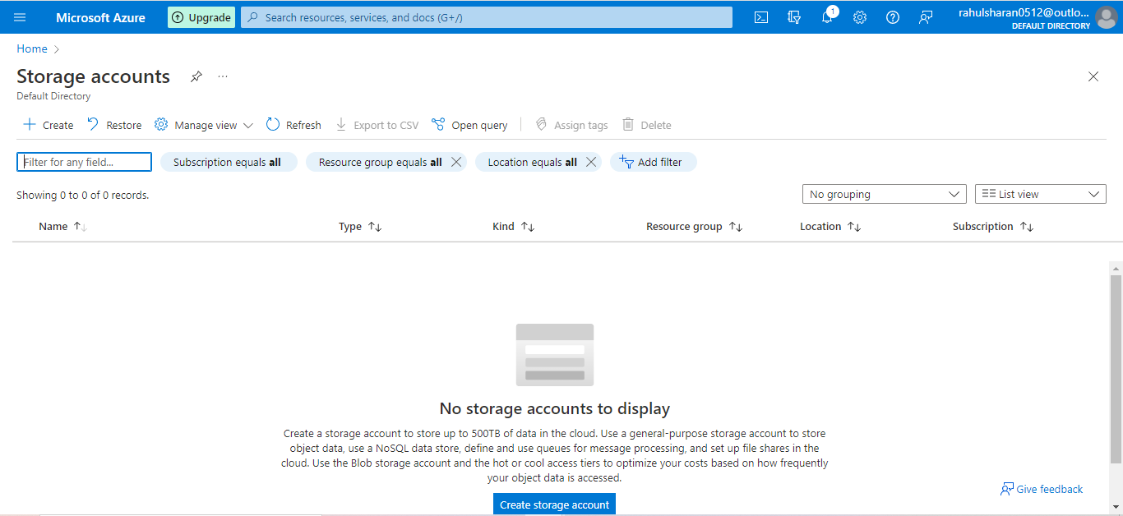

When you navigate to the **Review + create** tab, Azure runs validation on the storage account settings that you have chosen. If validation passes, you can proceed to create the storage account

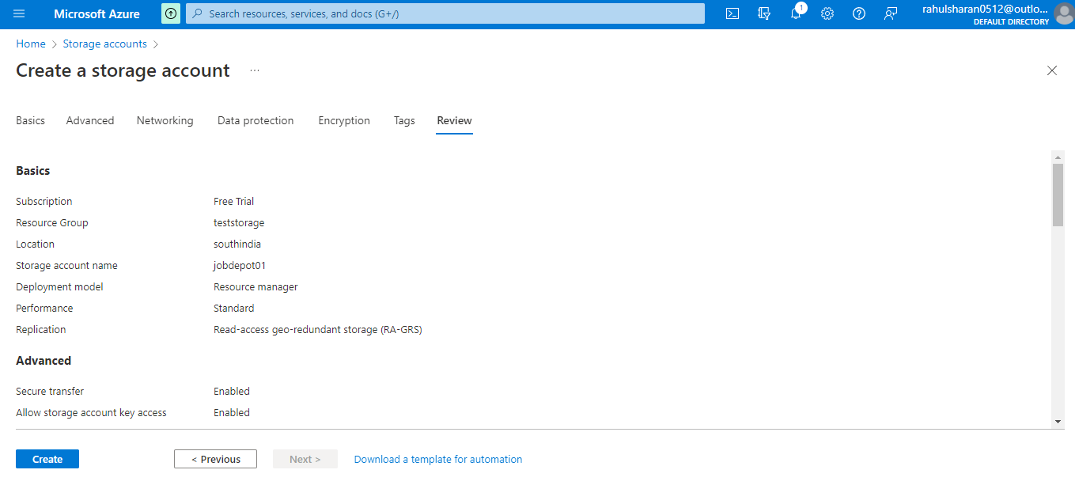

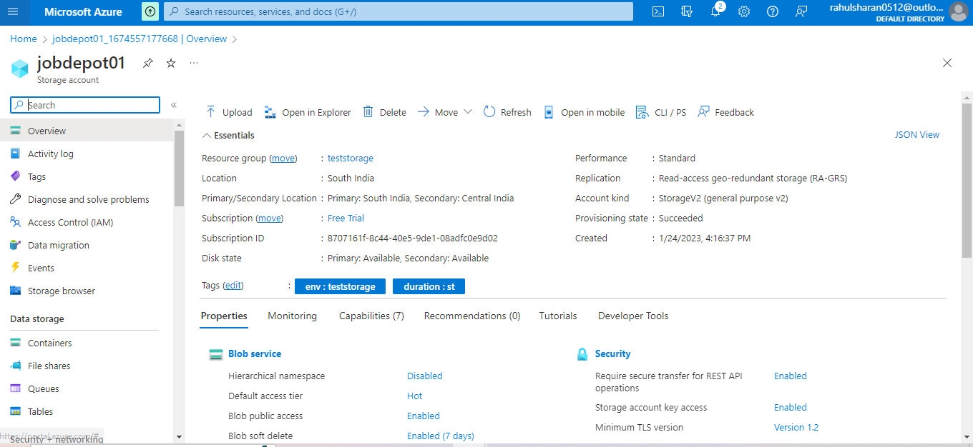

Manage blob storage

Azure Blob Storage is Microsoft's object storage solution for the cloud. Blob Storage is optimized for storing massive amounts of unstructured data. Unstructured data is data that doesn't adhere to a particular data model or definition, such as text or binary data.

To Create a Container.

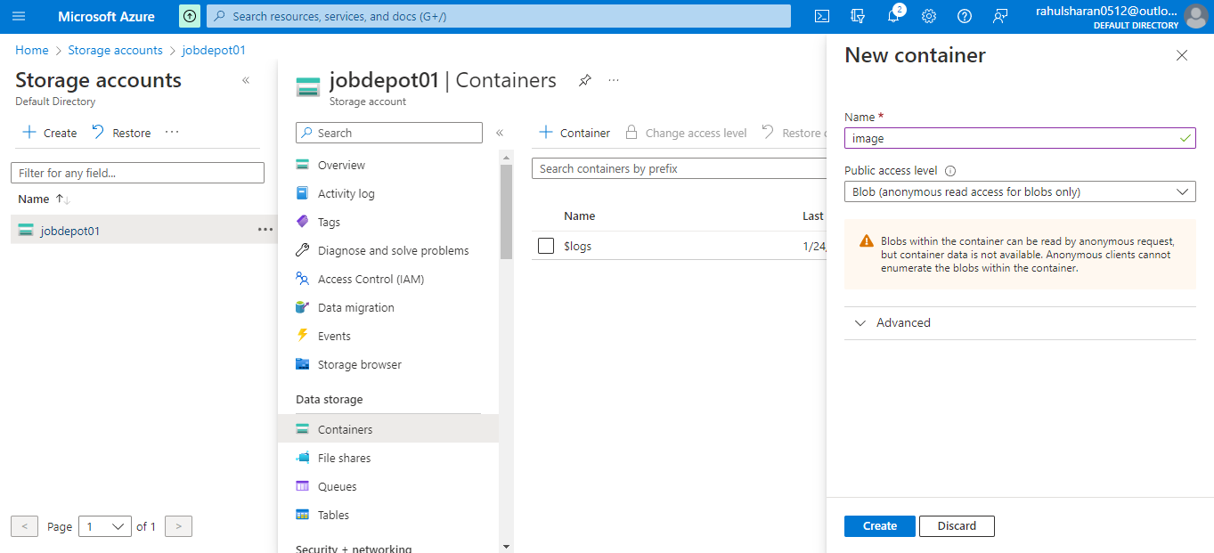

Successfully created storage container image, videos and audio.

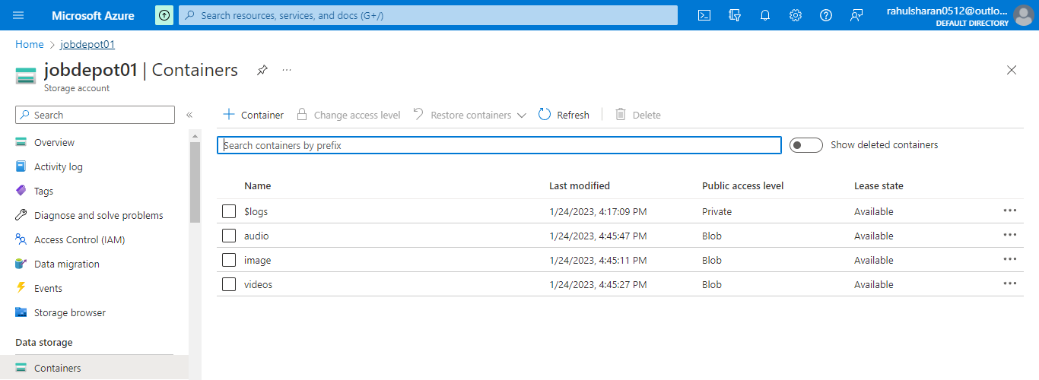

Successfully uploaded images, video and audio in storage container.

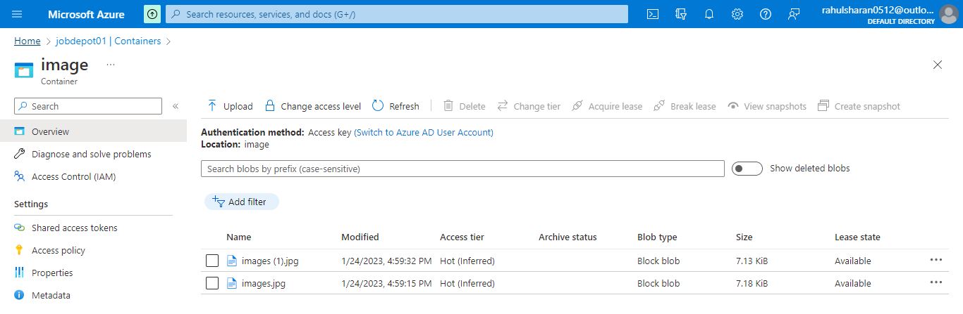

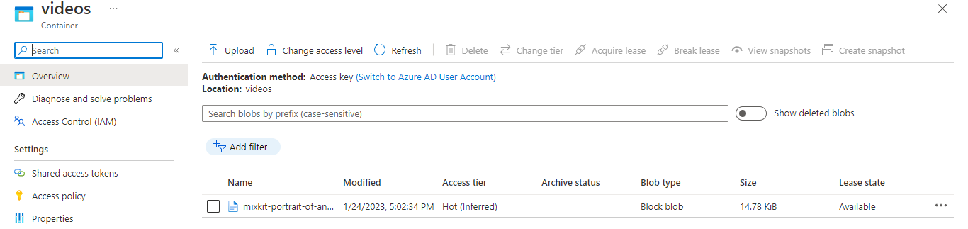

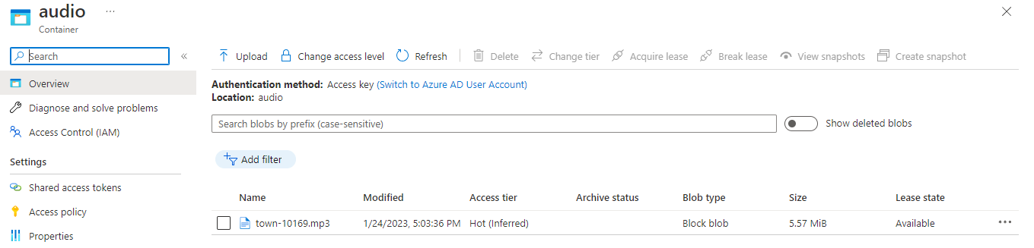

# Blob storage to display images, videos and audio in a web via public URL.

# 

# Successfully displayed image, video and audio via public URL.

# 

# 

# 

Properties of a container.

Manage container and blob access. Generate a shared access signature. Create a stored access or immutability policy. Manage leases- Acquire a lease, break a lease. Change access level-public and private Container metadata. Delete containers.

# 

To generate an SAS (shared access signature) token.

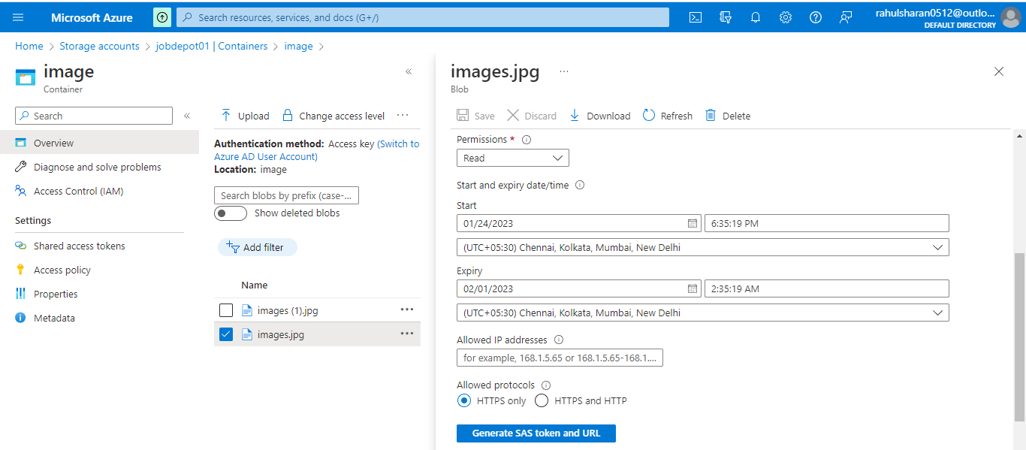

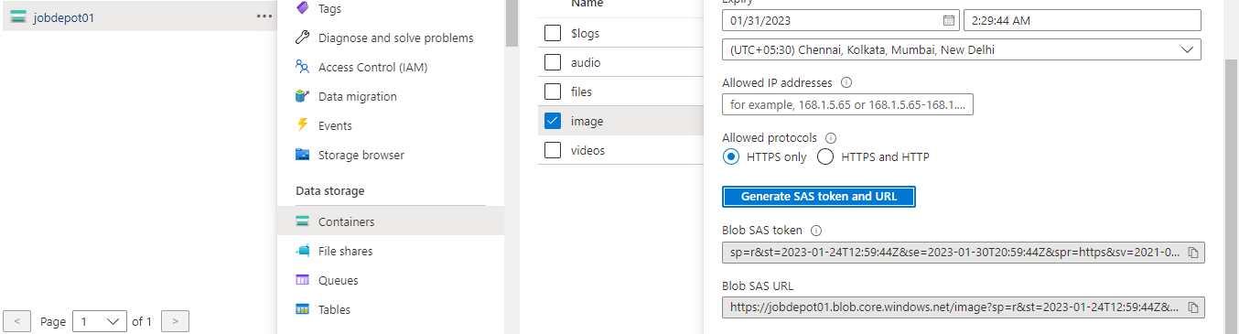

Successfully displayed image via Bob SAS URL.

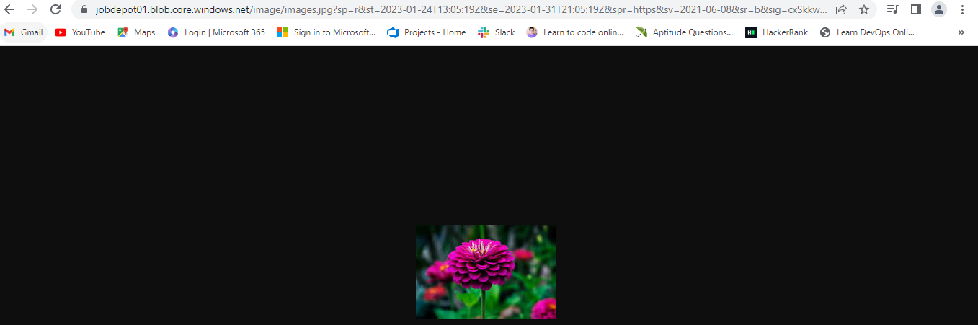

Enable public network access from selected virtual machine and IP address.

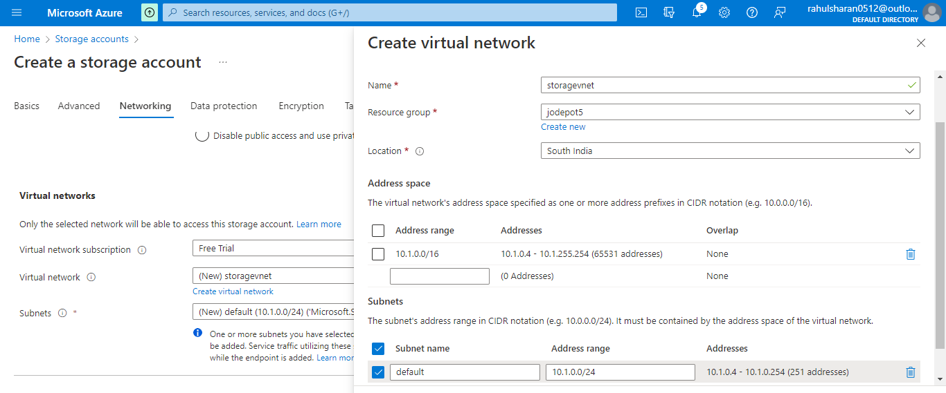

Disable public network access for public IPs.

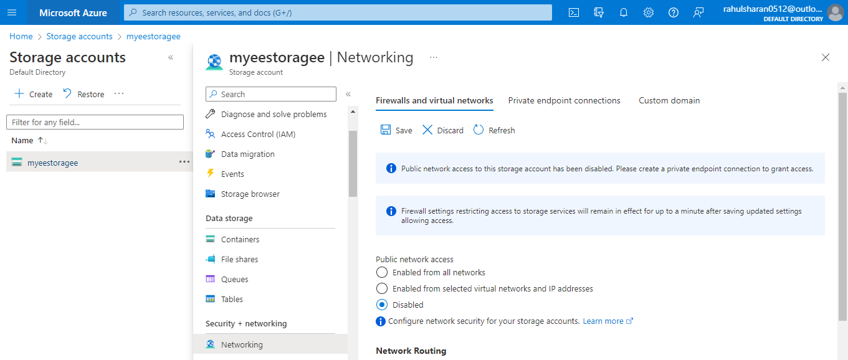

Add IP ranges to allow access from the internet or your on-premises networks.

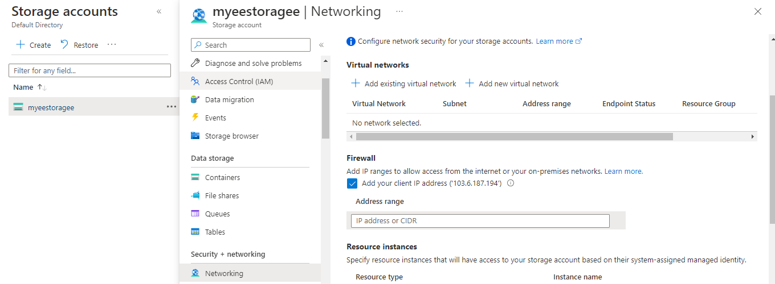

Create a private endpoint in storage account.

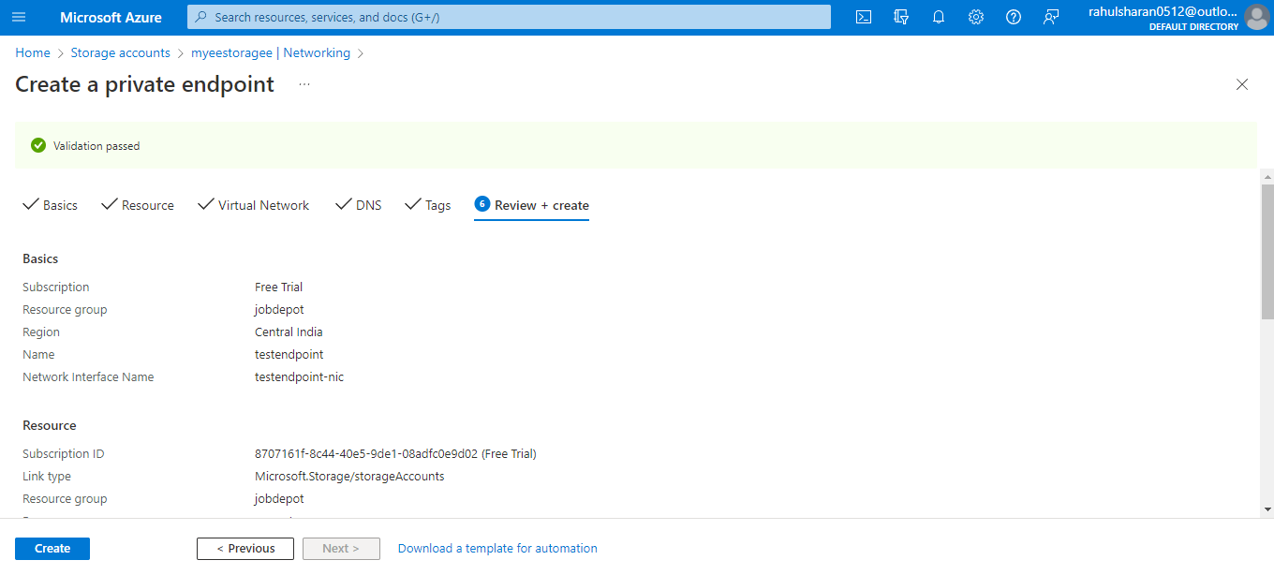

DNS Configuration and FQDNs.

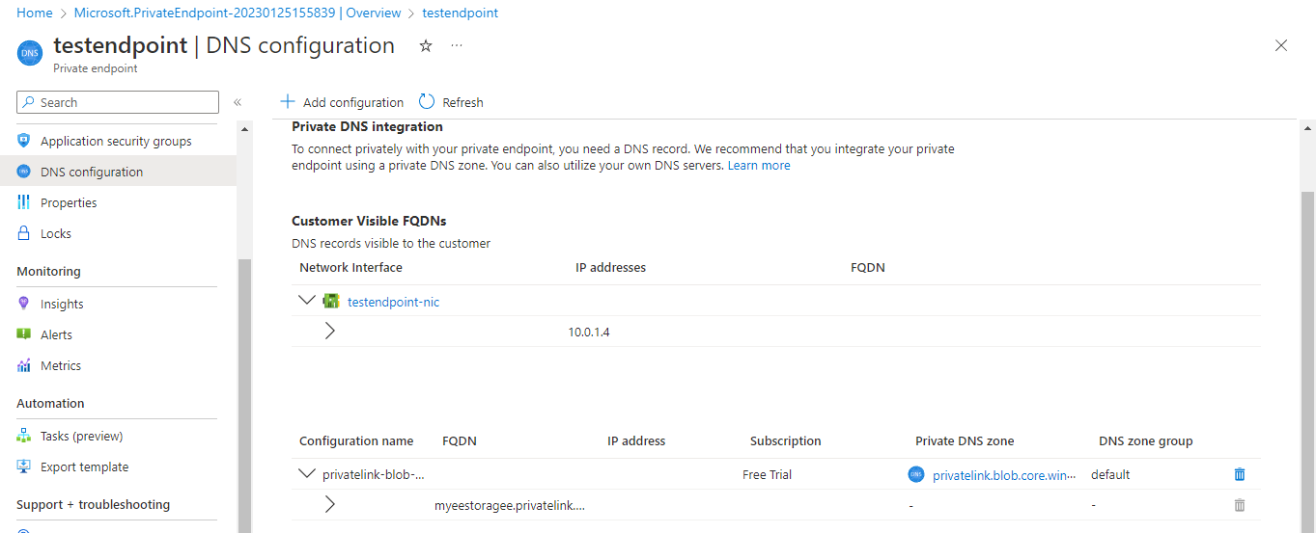

To change the tier in storage account.

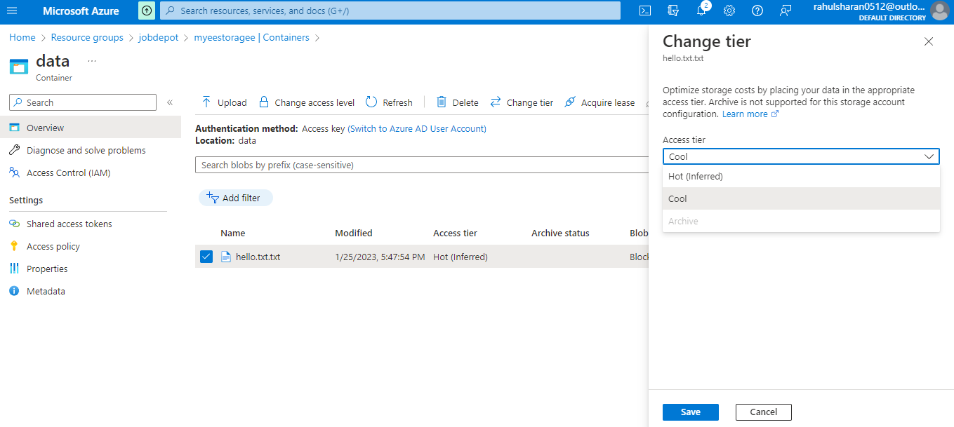

Successfully moved access tier (hot to cool) for blob 'hello.txt.txt'.

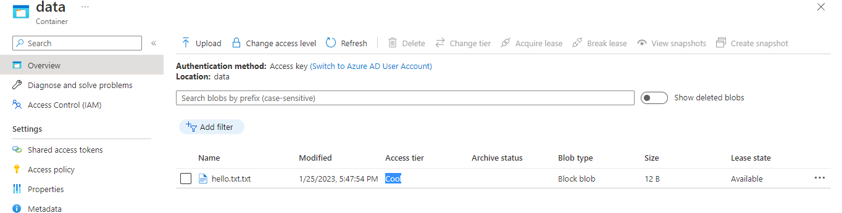

## Add rules in Lifecycle management in data management in storage account.

Storage account-> Lifecycle management->Add rule

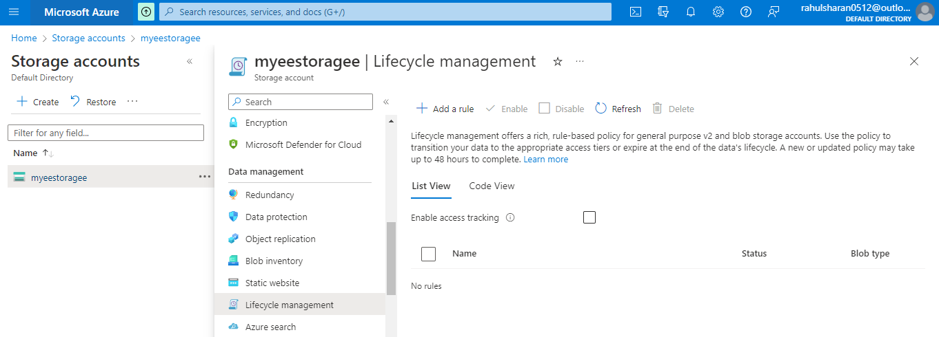

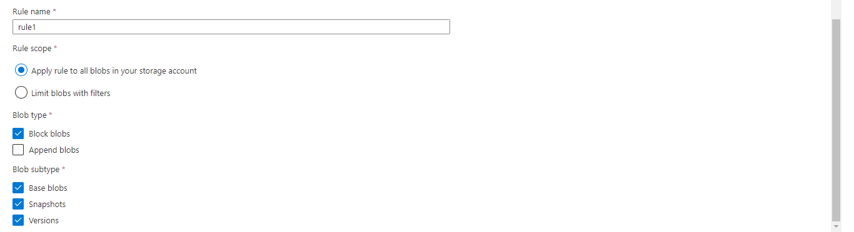

## Successfully created lifecycle management policy for storage account 'myeestoragee'.

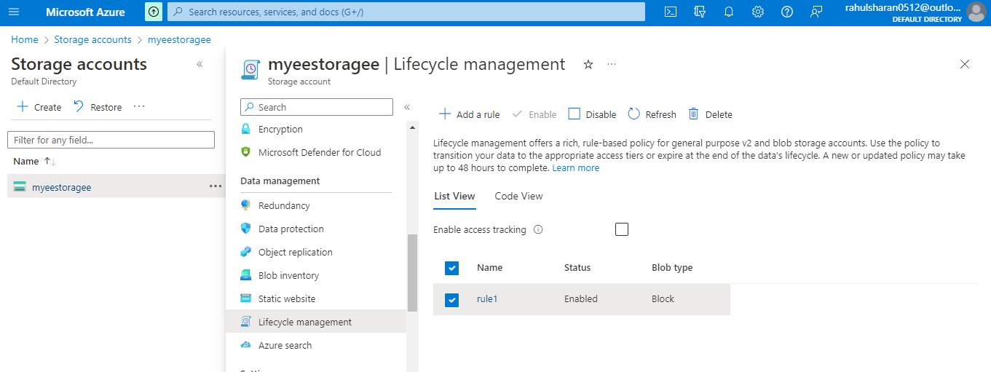

## To Change redundancy in data management in storage account.

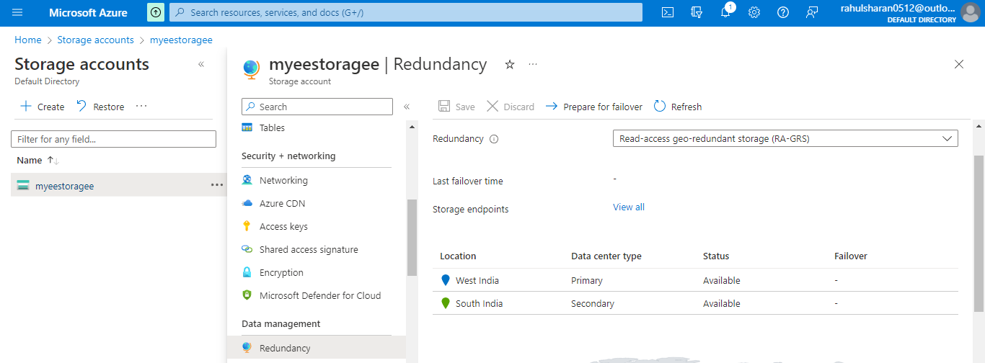

## Successfully changed redundancy type (RA-GRS to GRS) for the storage account 'myeestoragee'.

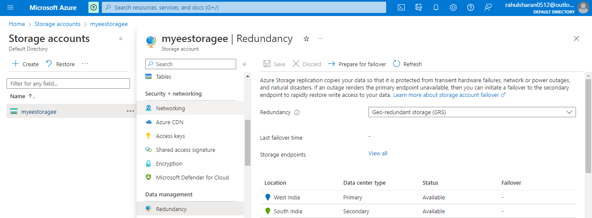

Create a key vault in azure portal.

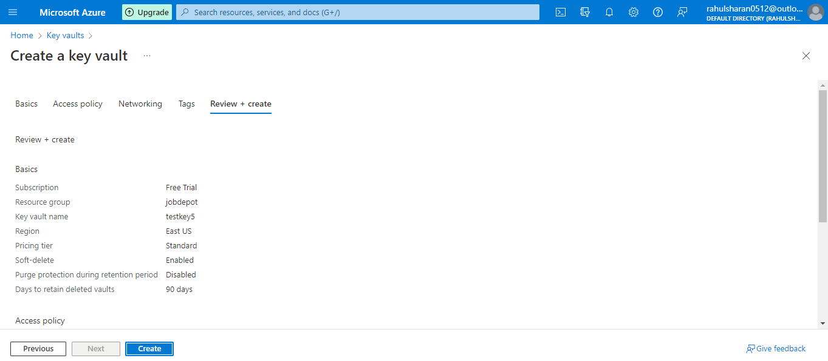

Create a key in key vault.

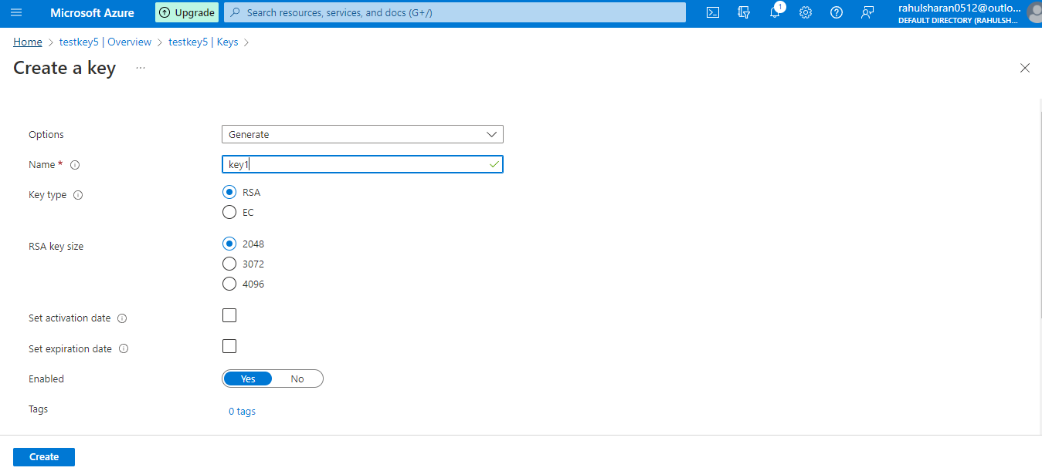

Create a secret in key vault.

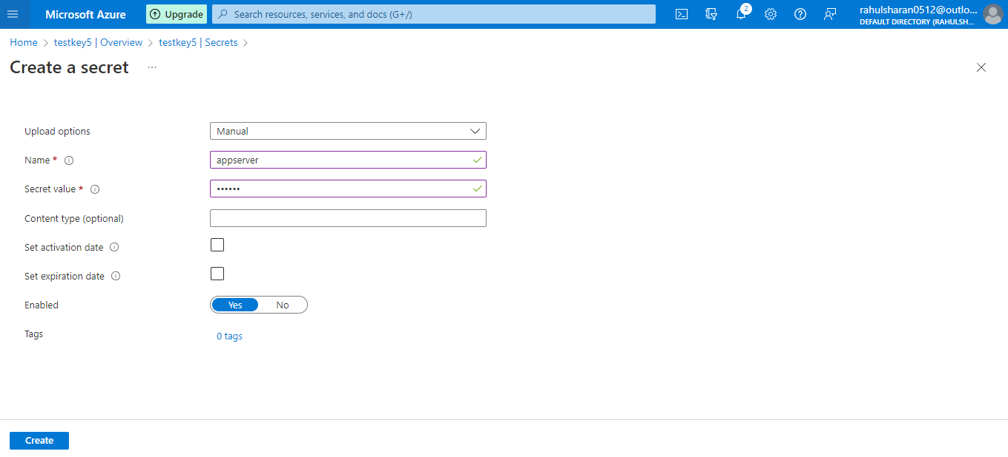

Create an access policy in key vault.

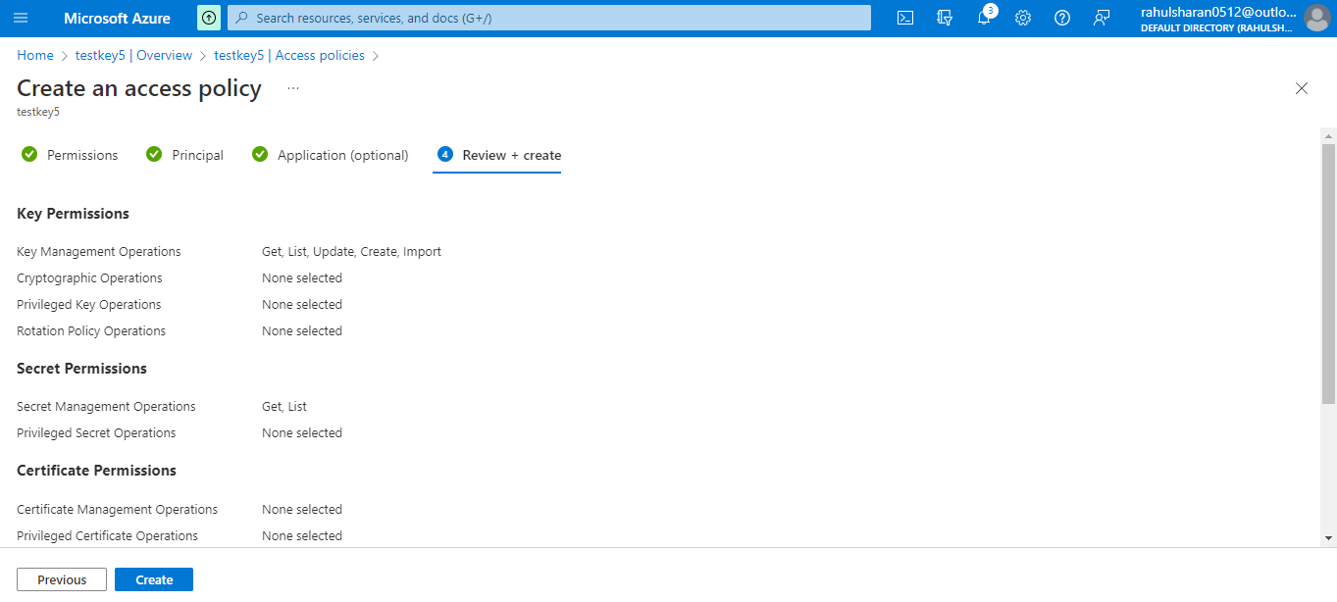

Create customer managed keys.

Storage accounts-> Encryption-> Encryption type: Customer-managed keys-> Encryption key: Select from key vault-> Key vault and key: Select a key vault and key->save

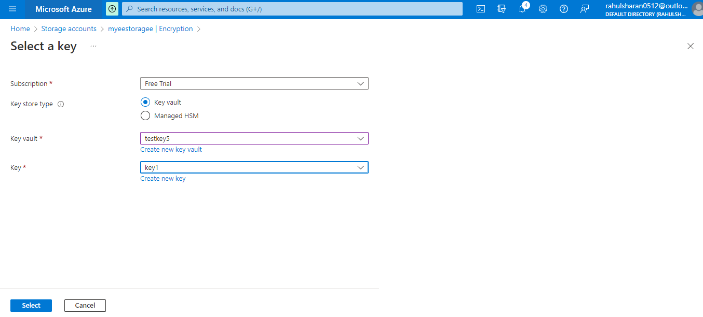

Create a file share in storage account.

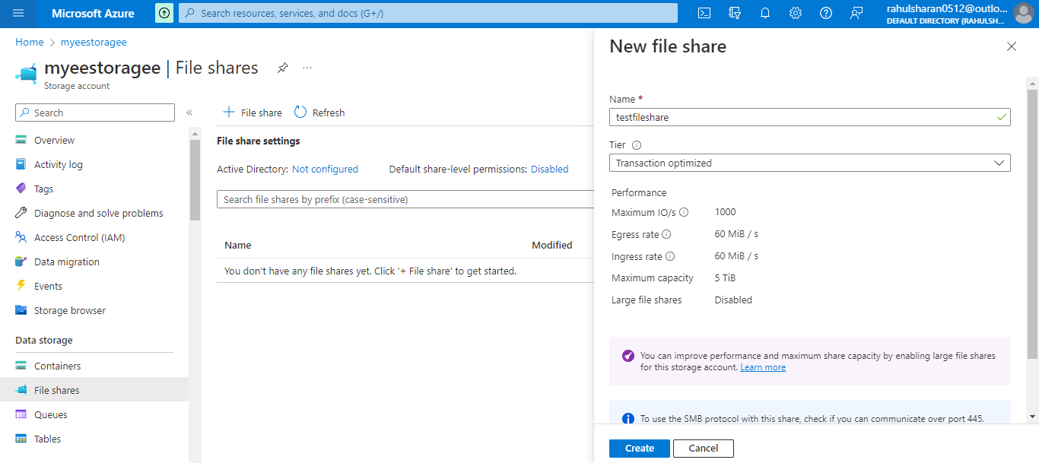

Successfully created storage file share.

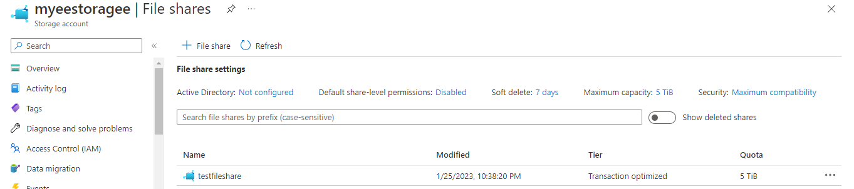

Successfully uploaded the files in file share.

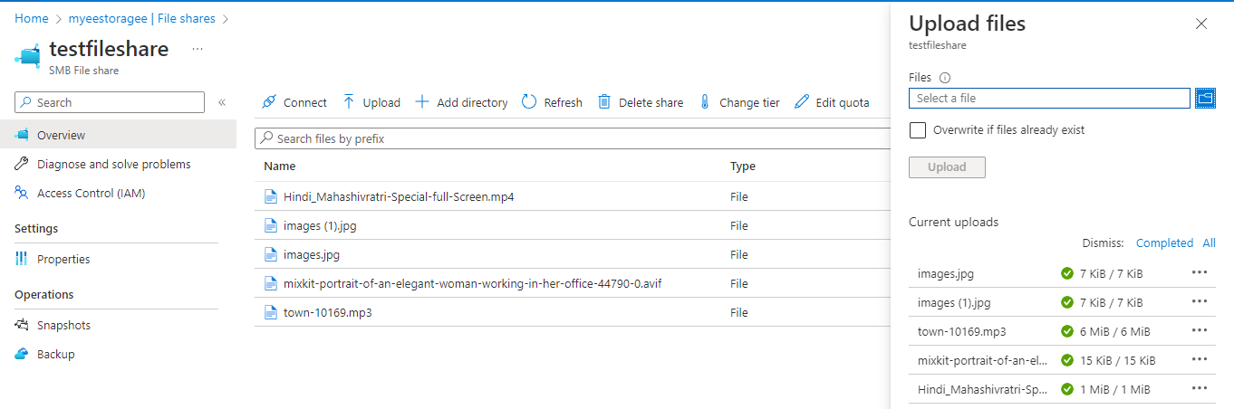

Connect files share with Virtual machine (appserver).

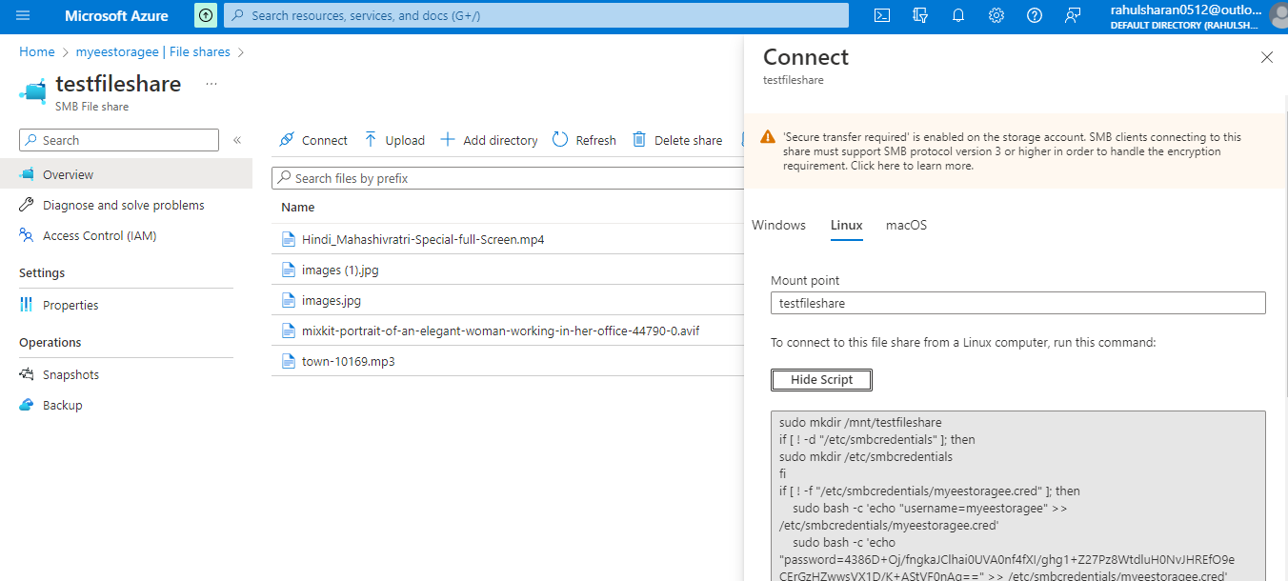

Run command script in appserver.

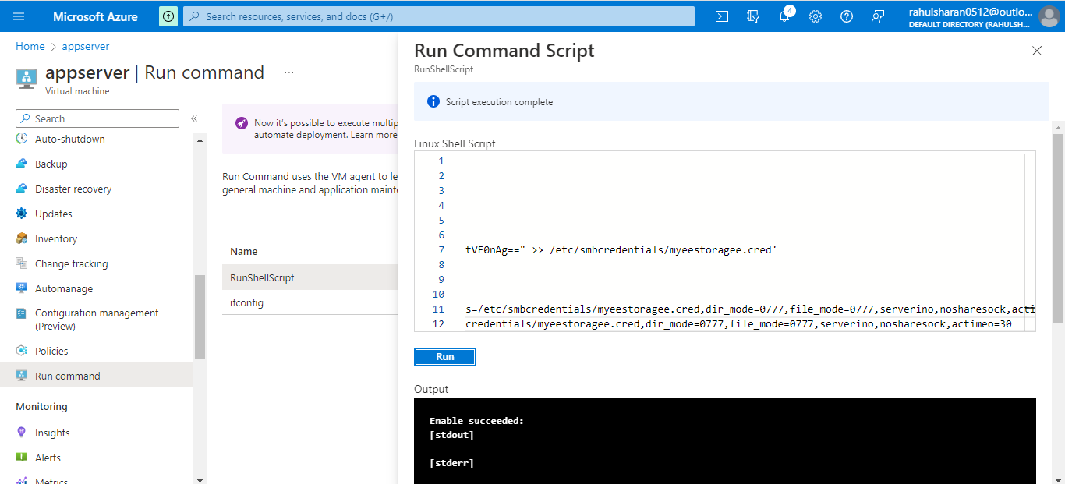

Successfully shared the file in appserver.

